Gist of the project

Asynchronous and synchronous Multi-Processing on multi-core processors

Kernel:
In short, it’s a vital part of your operating system, if not the most important. An operating system is responsible for letting your programs function, by allowing them access to your hardware. However, it’s which actually carries all these jobs out.
Symmetric Multi-Processing
Symmetric Multi-Processing is a multiprocessor software and hardware architecture in which two or more identical processors are connected to a single and shared main memory and are con-trolled by a single operating system which treats all processors equally, reserving none for special purposes. In the case of multi-core processor, the SMP architecture treats them as separate pro-cessors.

Asymmetric multiprocessing

In asymmetric multiprocessing system (AMP), not all CPUs are treated equally; for example, a system might allow only one CPU to execute operating system code or might allow only one CPU to perform I/O operations. Other AMP systems would do something different so that they were symmetric with respect to processor roles, but attached some or all peripherals to particular CPUs, so that they were asymmetric with respect to the peripheral attachment. AMP is used in applications that are dedicated i.e. when individual processors can be dedicated to specific tasks at design time.

Kernel Installation Steps:

The installation process for building the kernel is as follows
- Download stable Linux version
- Download Xenomai-3.0.5 version
- Collect stable I-pipe version
- Build essential Linux packages
- Patch Linux Kernel with Xenomai
- Configure Linux Patch
- Compile Kernel
- Testing the Kernel
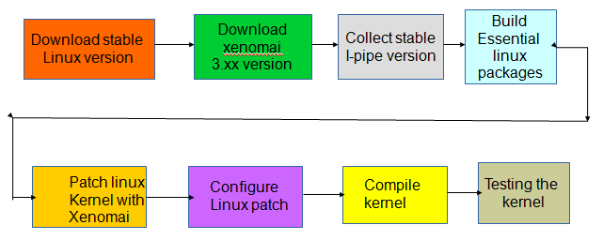

- Downloading stable linux source:
Stable linux lernel linux i.e Linux-4.9.51 has to be downloaded from the official website.
https://www.kernel.org/
2 Downloading Xenomai 3.0.5 version:
Xenomai-3.0.5 version has to be downloaded.
https://www.xenomai.org
3 Collecting Stable I-pipe Core:
Download the stable I-pipe core-4.9.51-x86-4 patch
4 Build essential packages in Linux:
Essential packages were built in downloaded Linux kernel using
“apt-get install build-essential gcc libncurses5-dev libssl-dev” libncurses5-dev package will make the kernel easier to configure.

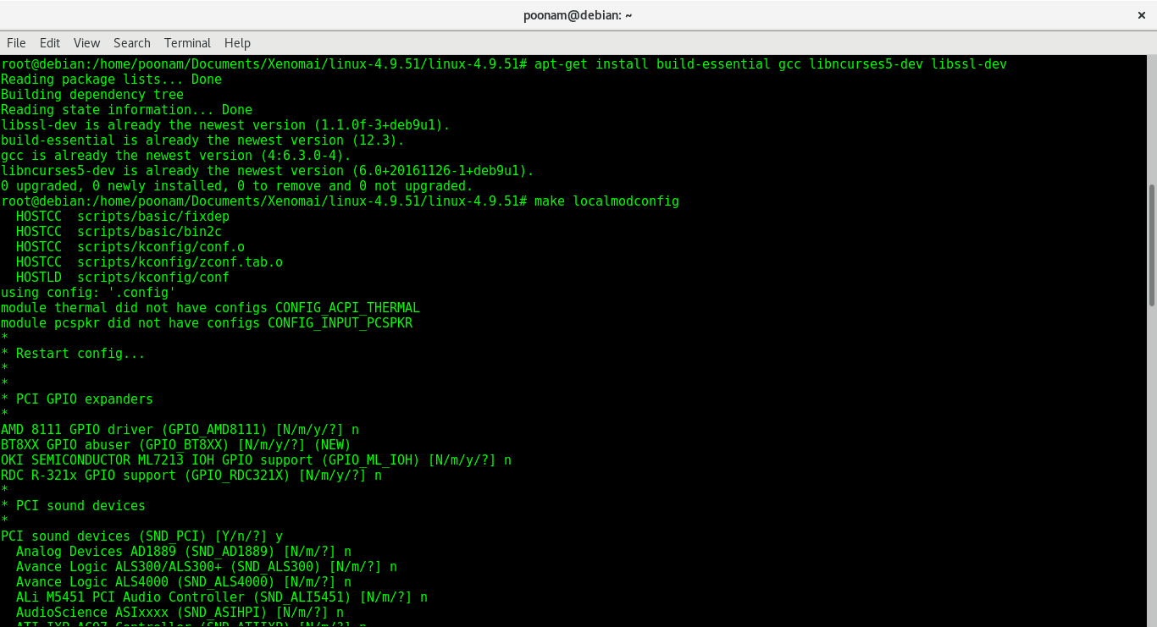

5 Patch Linux Kernel with Xenomai
Now we need to patch our downloaded stable linux kernel with Xenomai using
“/scripts/prepare-kernel.sh-linux=../../linux-4.9.51/linux-4.9.51/--ipipe=../../ipipe-core- 4.9.51-x86-4.patch-arch=x86-4”

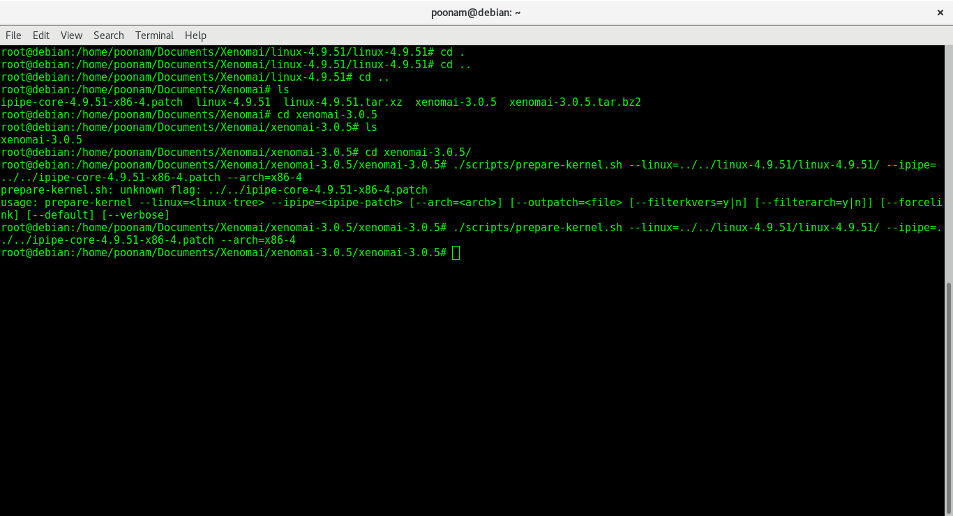

6 Configuring Patched Kernel:
Using “make localmodconfig” detects currently running kernel components and marks them for compilation.

“make menuconfig” is used to choose what to compile. Here we make changes and generate a config-fil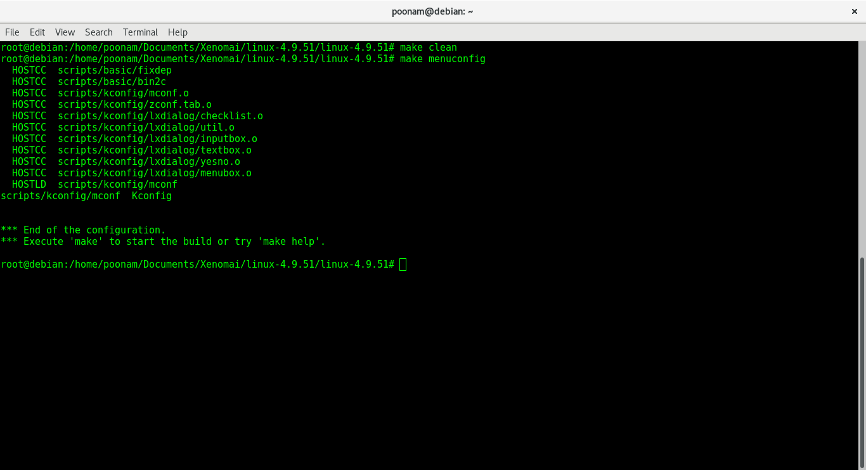KKernel configuration file:
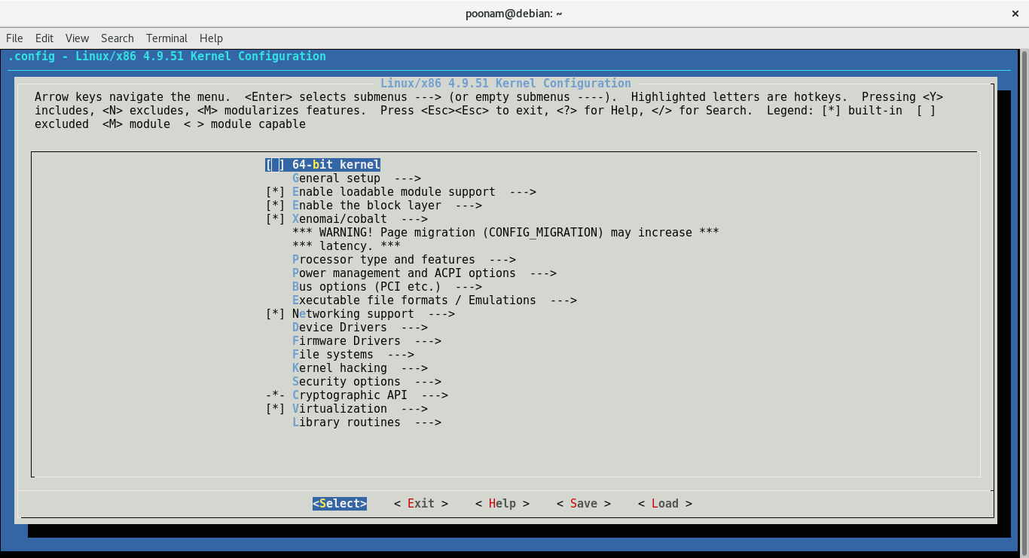
During configuring we need to enable and disable some settings

7.Power Management:
Power management should not be disabled globally, the only which are to be disabled in this area are
- CONFIG_APM
- CONFIG_ACPI_PROCESSOR
CPU Frequency scaling:
- CONFIG_CPU_FREQ – Disable
Numerous CPUs change the TSC tallying recurrence which makes it pointless for exact planning when the CPU clock can change.Also a few CPUs take a few milliseconds to increase to full speed. Along these lines, by impairing this enables the CPU to be regulated with workload.
- CONFIG_CPU_IDLE – Disable
This enables the CPU to enter profound rest states , expanding the time it removes to get from these rest states. Timers used by Xenomai stop functioning when entered into these sleep states.
- CONFIG_APM – Disable
Power management control to the BIOS is assigned by the APM model. Profiles code is never composed because of best inactivity. APM schedules are summoned with SMI need if designed, this sidesteps the I-pipe altogether.

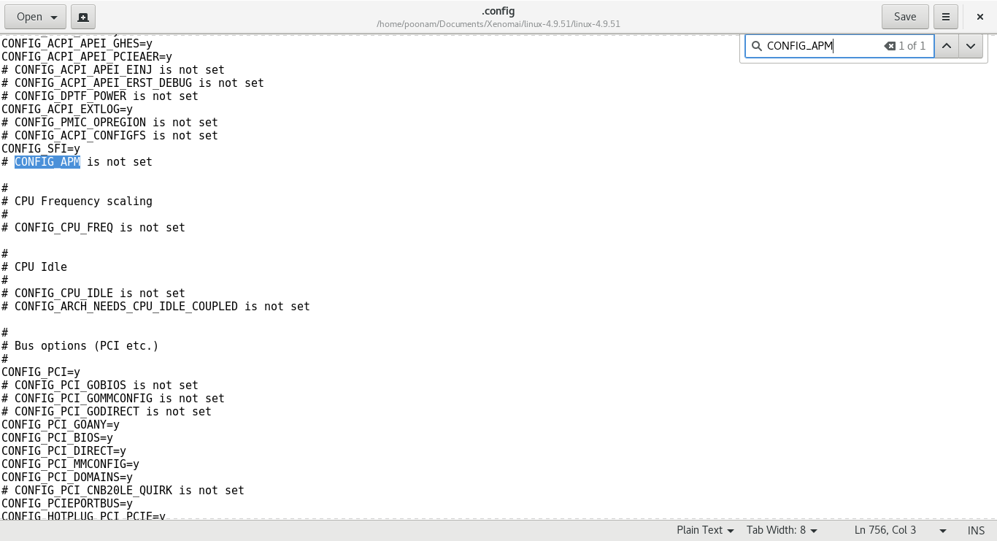

- CONFIG_ACPI_PROCESSOR – Disable
The ACPI processor module disables the local ACPI which will cause the Xenomai timer initialization to fail due to this reason we disable this option.

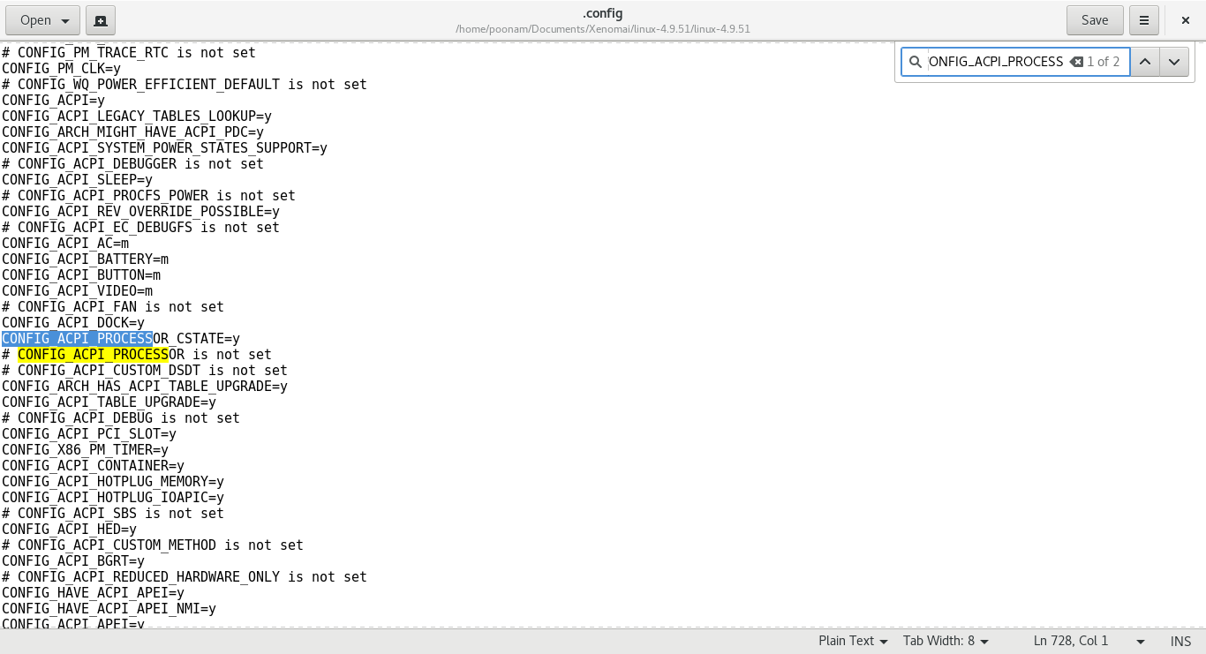
- CONFIG_INTEL_IDLE – Disale
This causes gigantic latencies in light of the fact that the ACPI clock that Xenomai uses may not fire any longer, additionally simply like CONFIG_ACPI_PROCESSOR, this sit driver sends the CPU into profound C states

- Disabling CONFIG_CC_STACKPROTECTOR:

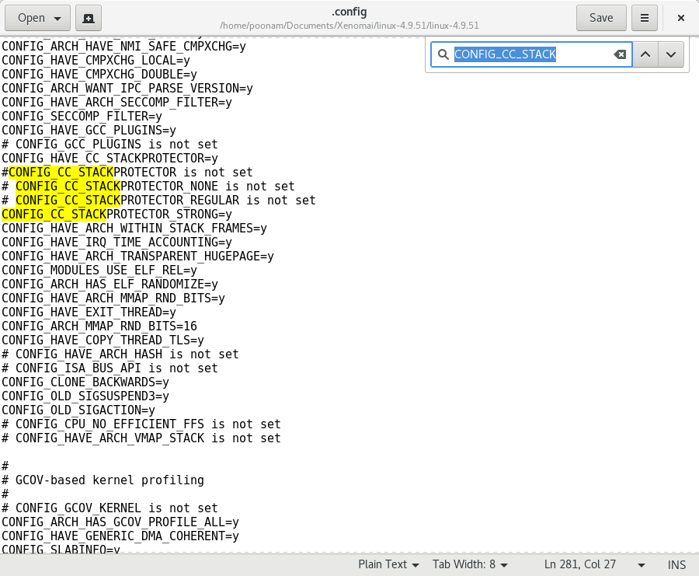

- Enable CONFIG_PCI_MSI: 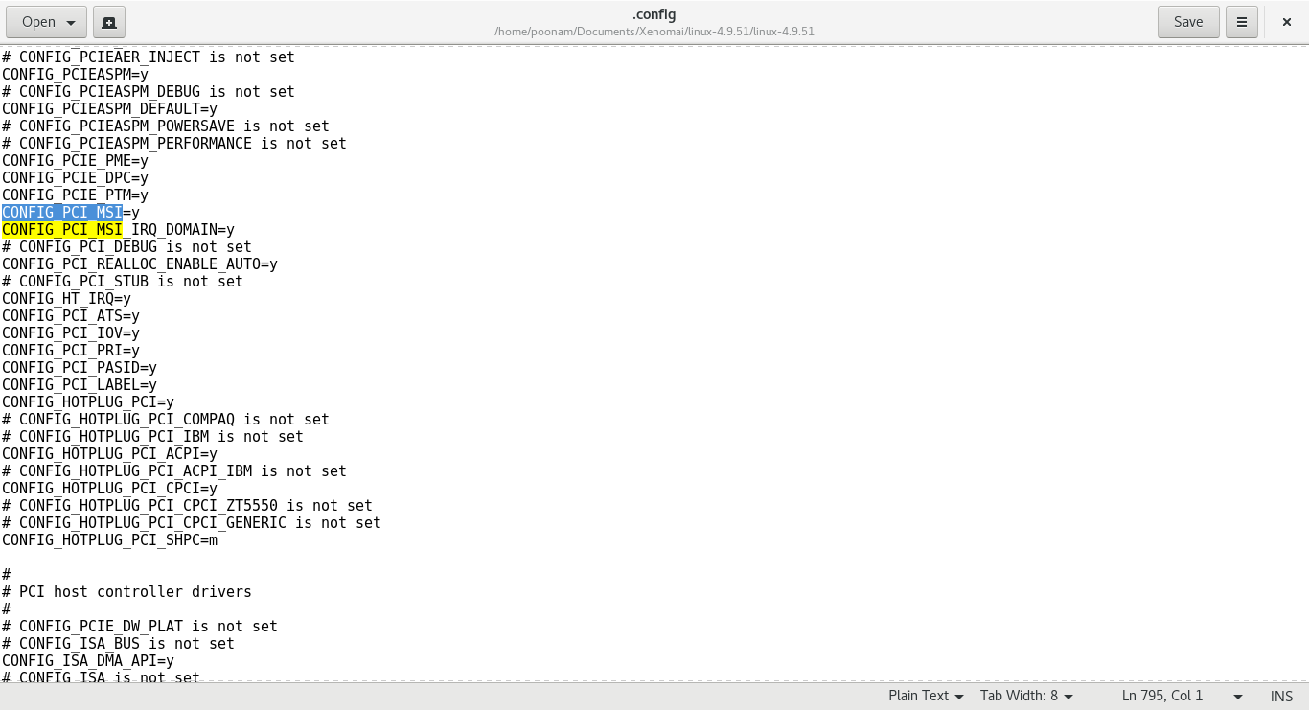
8. Compile Kernel:
Now we need to compile our linux kernel using
- “Sudo make-j$(nproc—all)”
This command is used to compile the kernel. “$” represents number of processors

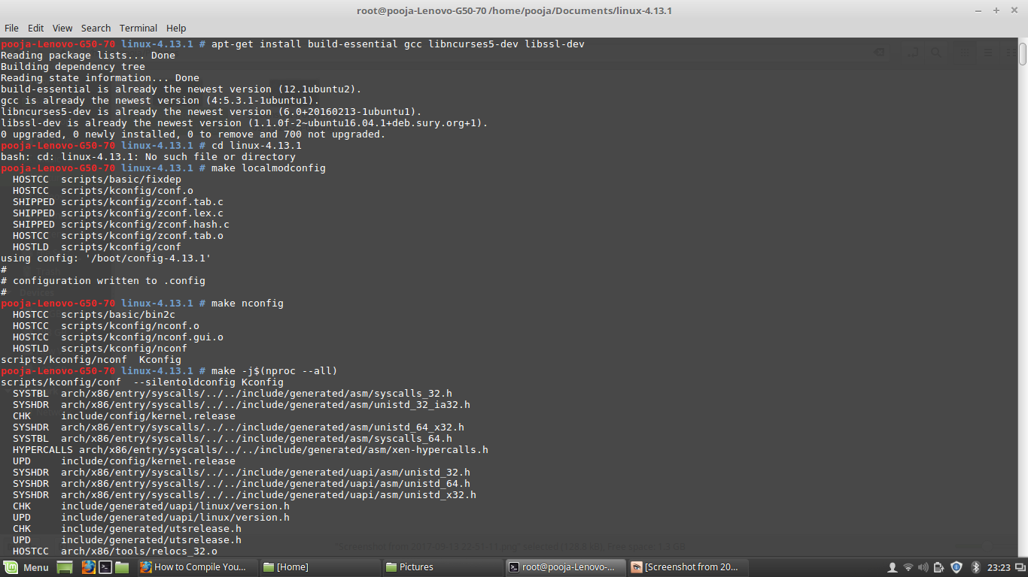

- “make modules_install”
This command is used to finish compiling the rest of the kernel
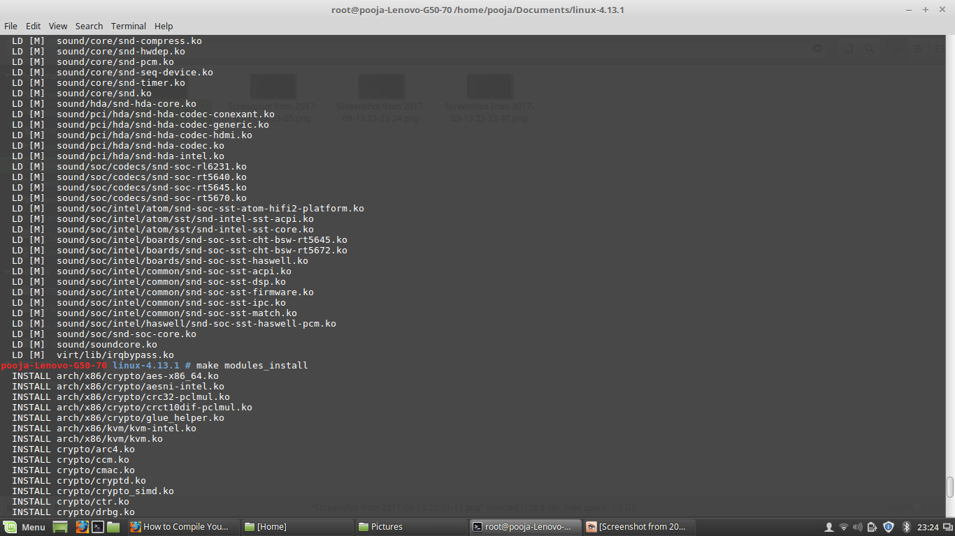

- “make install”
This will automatically copy the kernel to your / boot folder and generate the appropriate files to make it work.
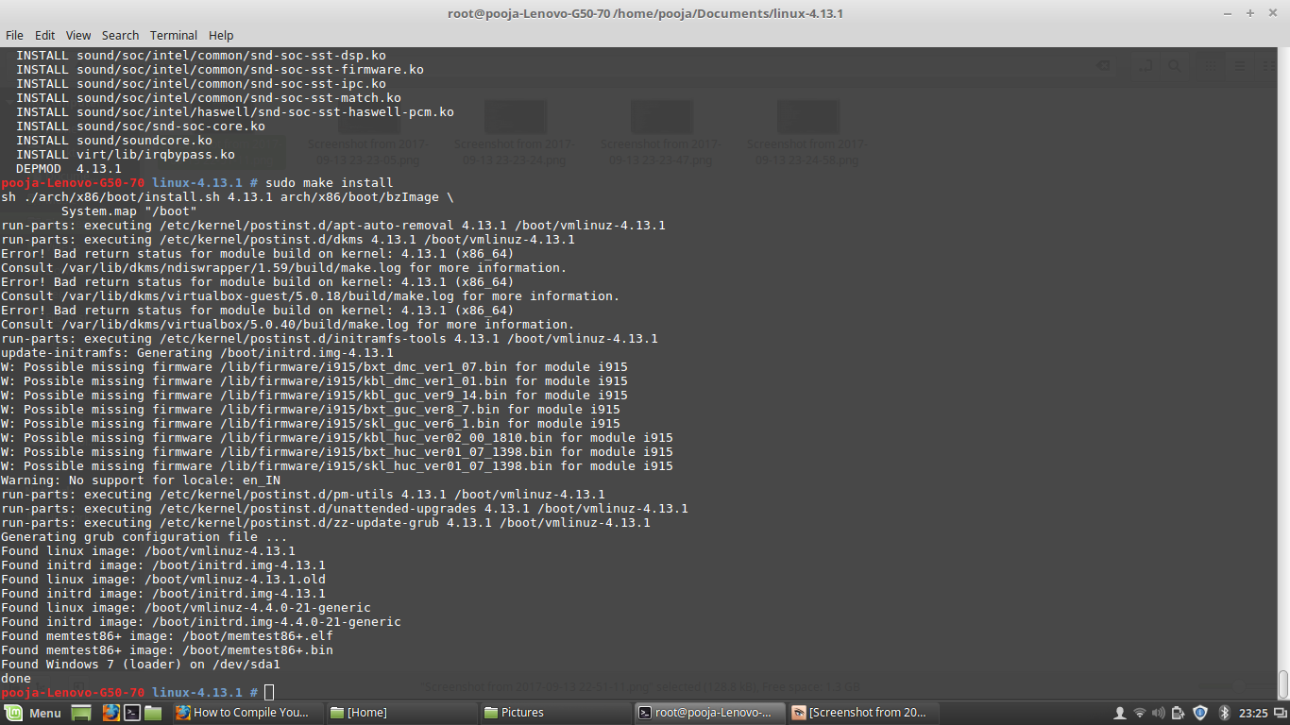

Available kernels after compilation:

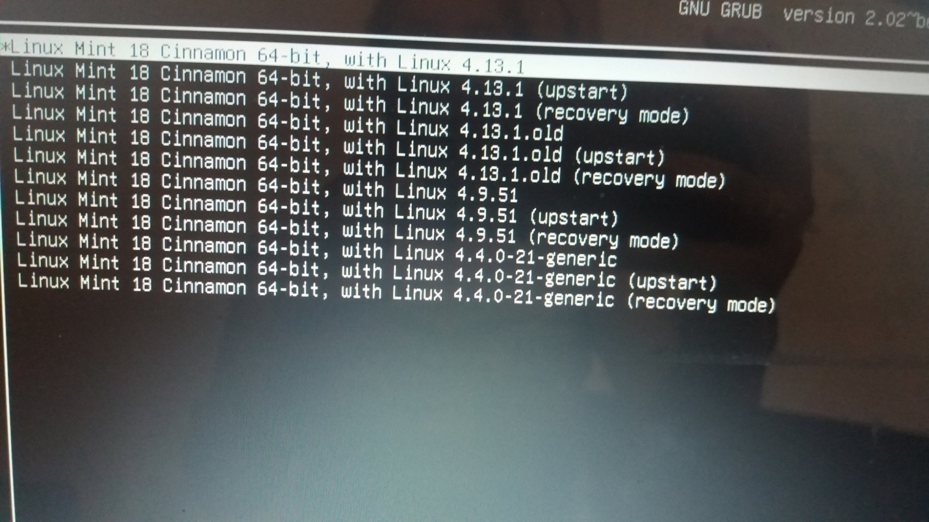

9. Functional Testing:

Test for Xenomai:
Before performing the functional tests, the first step is to search for the Xenomai whether it is present in our kernel or not?
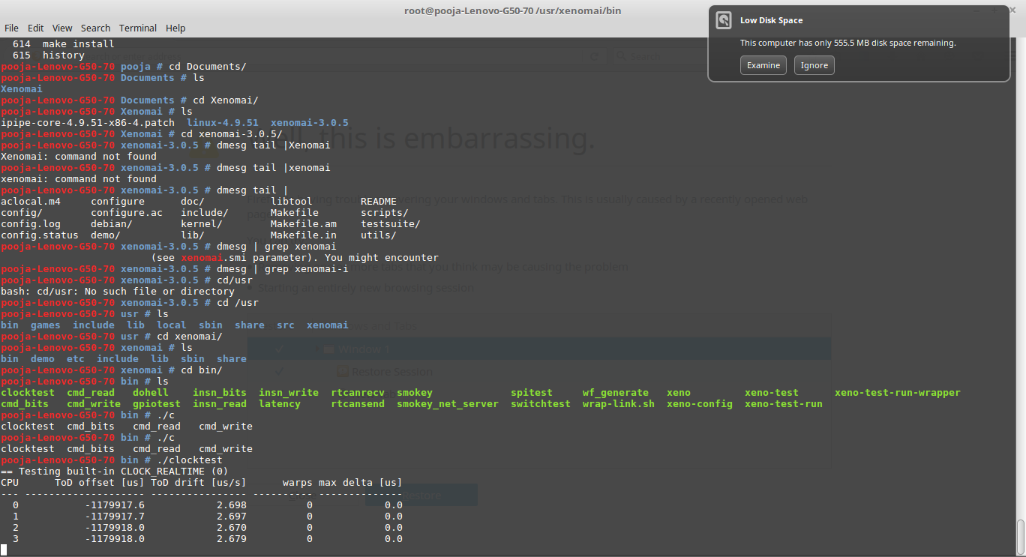
Latency Test:

Performing Latency test using ./latency
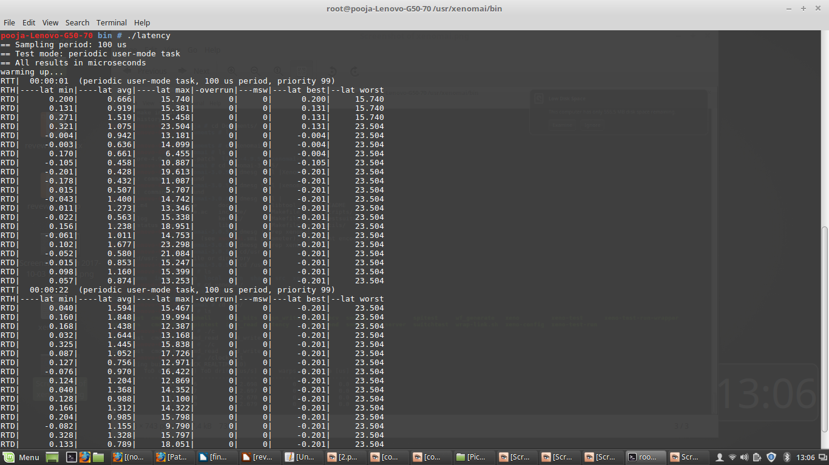

Arguments for Latency Test

-s : Prints Statistics of min, max and average latencies
-T : Test duration in seconds
-t : 0 = User task
1= Kernel Task
2 = Timer Task
-P : Priority of the Task

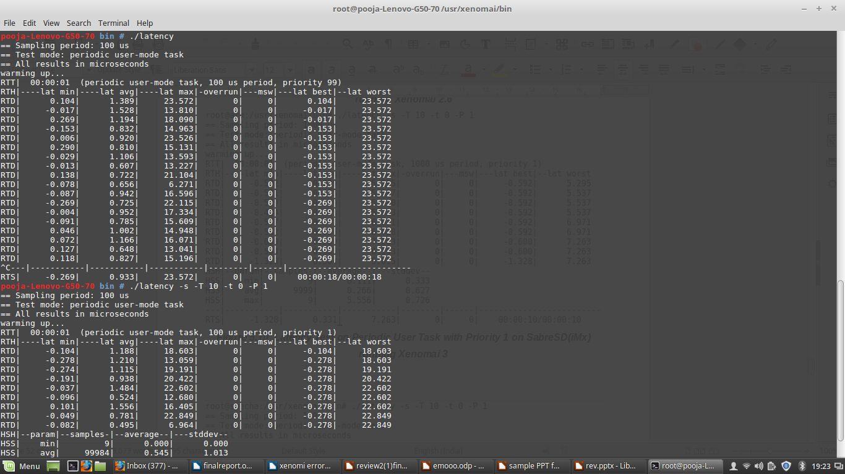

Clock test:

Performing Clock test using ./clocktest 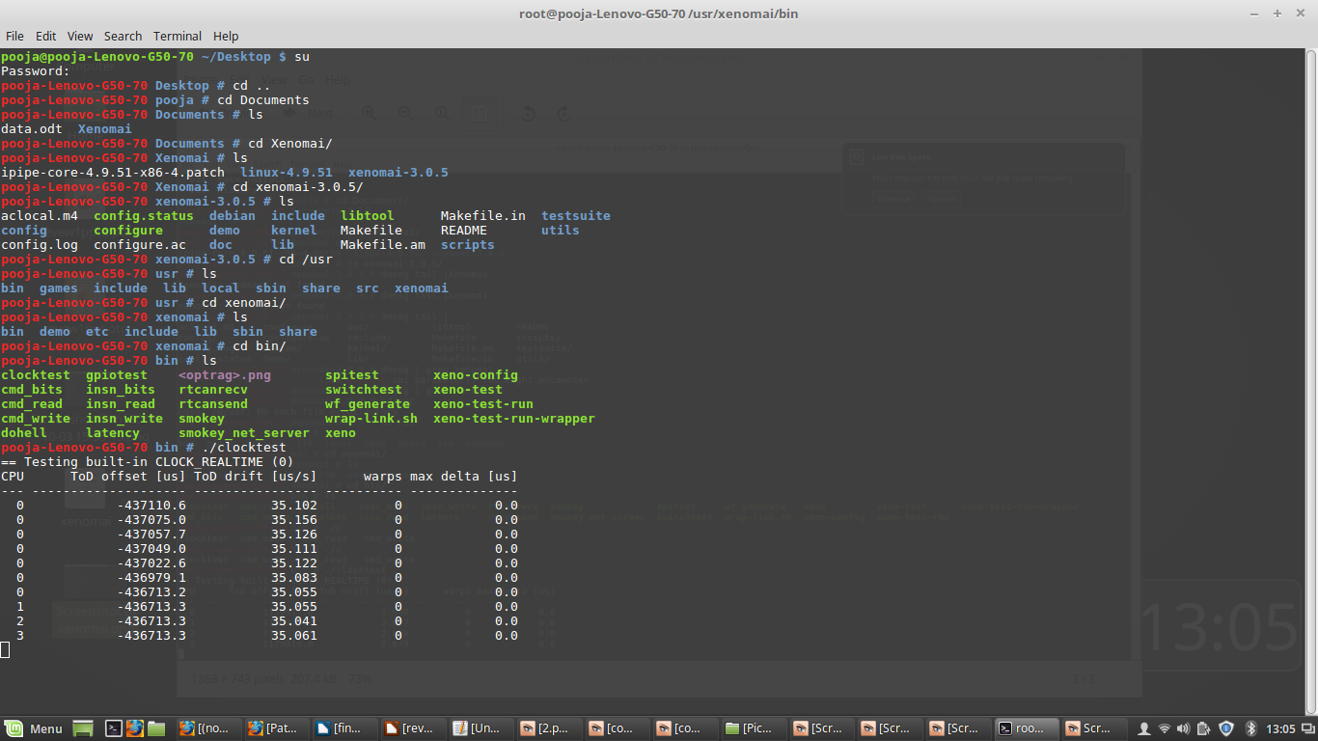

Arguments for Clock test

-C : Clock ID
Usage: -C0 = Real time Clock
-C1 = Monotonic Clock
-T : Test Duration in Seconds
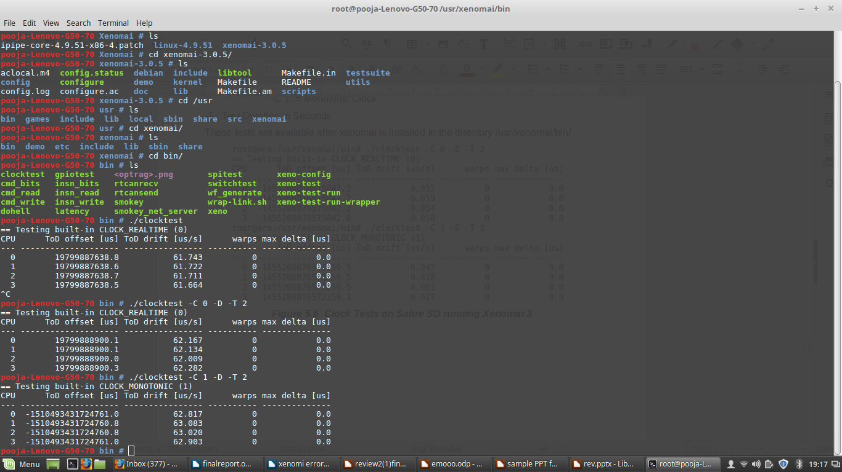

Switch Test:
Performing switch test using ./switchtest.

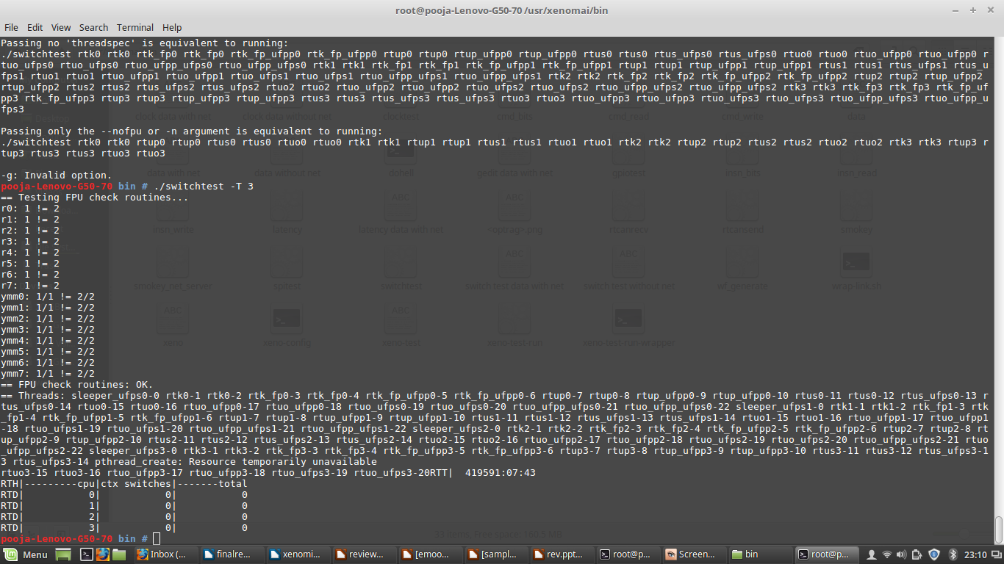

Arguments for Switch test
T- Time duration for every second.

10. Implementing Asymmetric Multiprocessing :
In order to implement Asymmetric processing first we need set few pre-requisites.
- Preferred Platform
- Selection of CPU
- Kinds of tests to be performed
Preferred Platform:
We have chosen Linux to be the suitable platform because of its Free and Open Source Nature having a larger community working towards solving problems. Support of the community and availability of API can be used to solve real time problems. Hence we implemented asymmetric processing on Linux kernel .
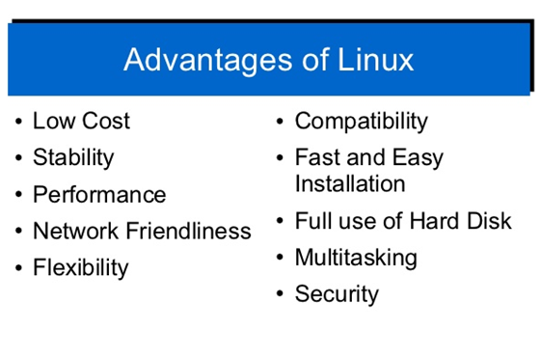
Selection of CPU:
We have implemented asymmetric multi processing on various multi core processors like a. x86 i3 processor with Frequency- 1900 MHz. b. AMD II X3 720 Processor, Frequency- 800 MHz and c. x8 i5 Processor, Frequency- 1400.158 MHz. The system performance and latency was measure for the same. We chose general purpose computing platforms as a base to test the computational power as we are testing the system to work as a IoT Gateway Server.
Performing tests :
At first we have created many threads using POSIX APIs and set priority the tasks .Later by using scheduler we assigned the tasks to the specific CPU cores.
For example if there are 10 tasks , and if tasks 2, 7 are assigned to CPU1 and 1,4,8,9,10 are assigned to CPU3 and tasks 3,5,6 are assigned to CPU4,Here CPU2 is left idle. Then the CPU 1,3,4 perform only related and internal tasks where as CPU2 performs only internal tasks, rest of the time it remains idle. Hence in this way we have implemented asymmetric processing on multi core and checked for CPU performance and measured the start time, end time and latency of all the tasks.
Methodology:
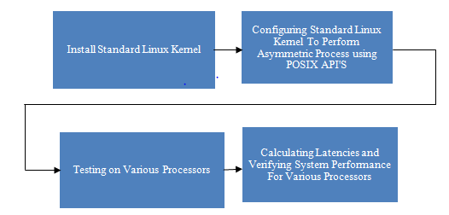

Installing Standard Linux Kernel.
The first step is to install standard Linux kernel and configuring the kernel to perform Asymmetric Multi Processing.

Configuring standard Linux kernel for Asymmetric multi processing using POSIX API’S.
After installing Standard Linux kernel we implemented multi processing with the help of POSIX (portable operating system interface) threads.
We implement multi processing by creating and processing large number of POSIX threads .As a part of asynchronous multi processing, we allocated specific threads to a particular processor. We defined 4 tasks and tasks were assigned to each processor

Testing on various processors
Next we worked on various processors to implement asynchronous process by creating and processing a number of threads where threads were assigned to process specific tasks. We implemented multi processing successfully and thread parameters for each thread are obtained.

Calculating Latencies and verifying system performance for various processors.
After getting the thread related parameters by asynchronous processing, we found latency for each thread. It gives timing for each thread, which is most important for an real time operating system. We also verified multiprocessing on the system level using system monitor performance. Later the graphs were plotted for asynchronous processing for various processors
Test for performance:
After the successful building of the kernel, we need to test the behavior and performance of the kernel to justify the real time behavior of the kernel. To verify the functional behavior and performance metrics of the kernel, we need to carry some standard test benches like latency test.

Asynchronous Processing on Multi Core Processors
Various threads were created and each thread is given a specific task.
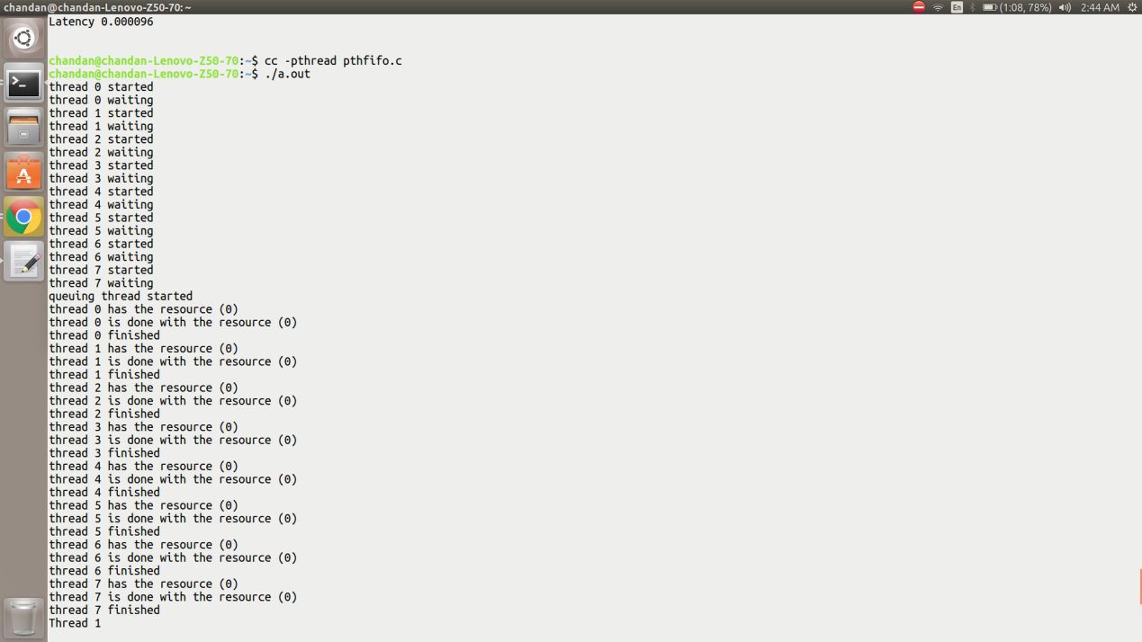

Creation of threads latency time and end time of each thread.
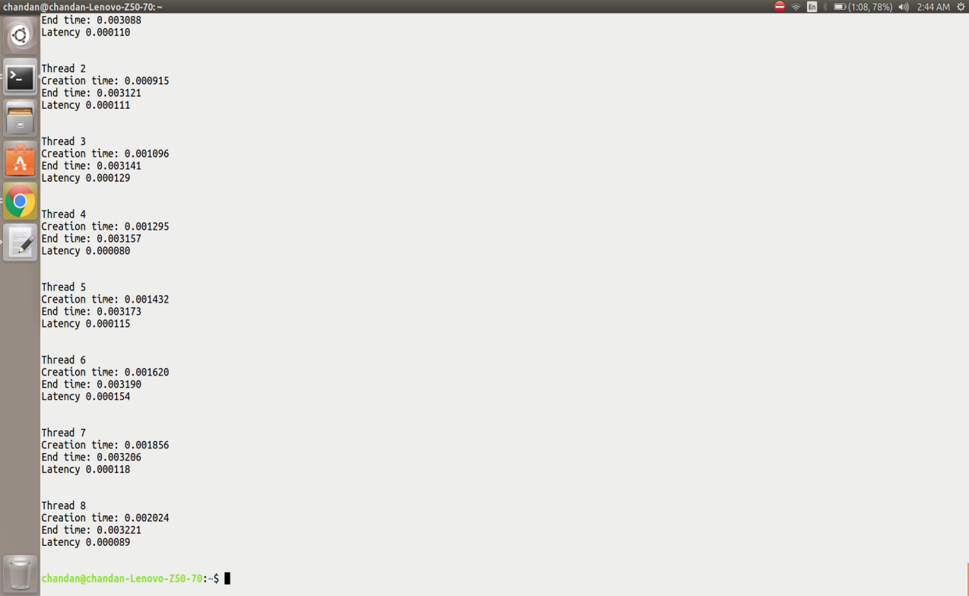

Asynchronous Processing on standard Linux kernel (AMD II X3 720 Processor, Frequency- 800 MHz

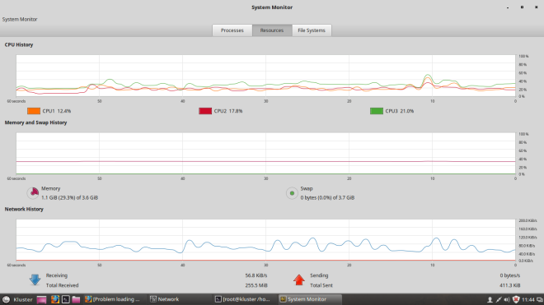

Asynchronous Processing plot on standard Linux kernel (AMD II X3 720 Processor, Frequency- 800 MHz
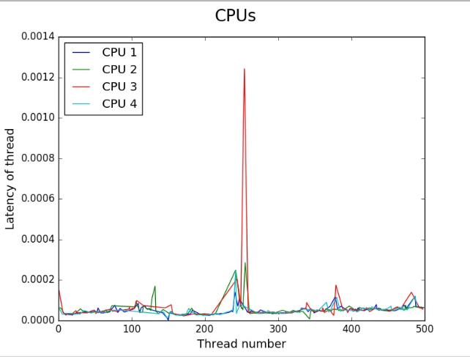

Asynchronous process on standard Linux kernel (x86 i3 processor, Frequency- 1900 MHz)
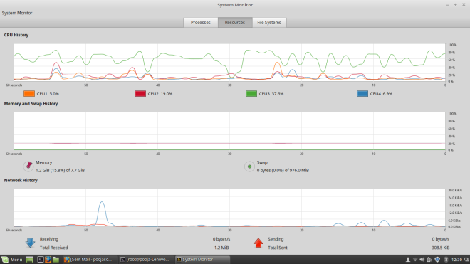

Asynchronous Processing plot on standard Linux kernel (x86 i3 processor, Frequency- 1900 MHz

Asynchronous Processing plot on standard Linux kernel (x86 i5 processor, Frequency-1400.158 MHz).

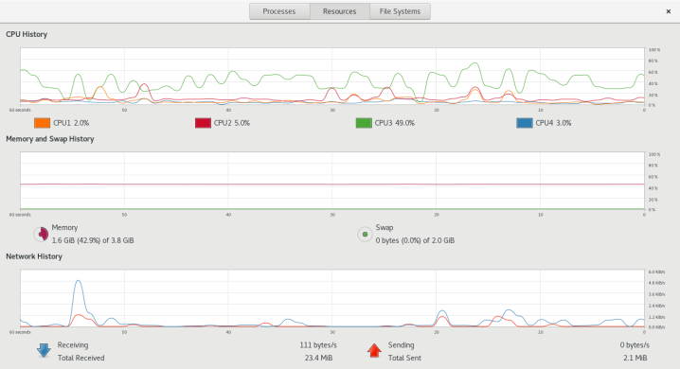

Asynchronous Processing plot on standard Linux kernel (x86 i5 processor, Frequency-1400.158 MHz).
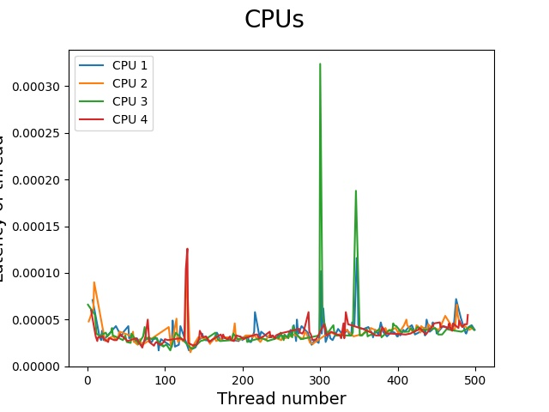

11.Discussion on Results:
We took a stable Linux Kernel and downloaded stable Xenomai version, collected a stable I-PIPE core to patch with Xenomai. Essential packages were built in the stable Linux kernel. Later Linux kernel was patched with Xenomai and configuration was done. Then compiled it and functional tests like Latency, Switch and clock tests were performed to measure the performance.
We have implemented asymmetric multi processing on various multi core processors like a. x86 i3 processor with Frequency- 1900 MHz. b. AMD II X3 720 Processor, Frequency- 800 MHz and c. x8 i5 Processor, Frequency- 1400.158 MHz. The system performance and latency was measure for the same. We chose general purpose computing platforms as a base to test the computational power as we are testing the system to work as a IoT Gateway Server.
At first we have created many threads using POSIX APIs and set priority the tasks .Later by using scheduler we assigned the tasks to the specific CPU cores.
For example if there are 10 tasks , and if tasks 2, 7 are assigned to CPU1 and 1,4,8,9,10 are assigned to CPU3 and tasks 3,5,6 are assigned to CPU4,Here CPU2 is left idle. Then the CPU 1,3,4 perform only related and internal tasks where as CPU2 performs only internal tasks, rest of the time it remains idle. Hence in this way we have implemented asymmetric processing on multi core and checked for CPU performance and measured the start time, end time and latency of all the tasks.

